UNIVERSITY OF UTAH/PEDIATRICS – SHAKTI KRUPA TRUST PARTNERSHIP

CURRENT HEALTH PROGRAMS

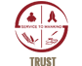 |  | 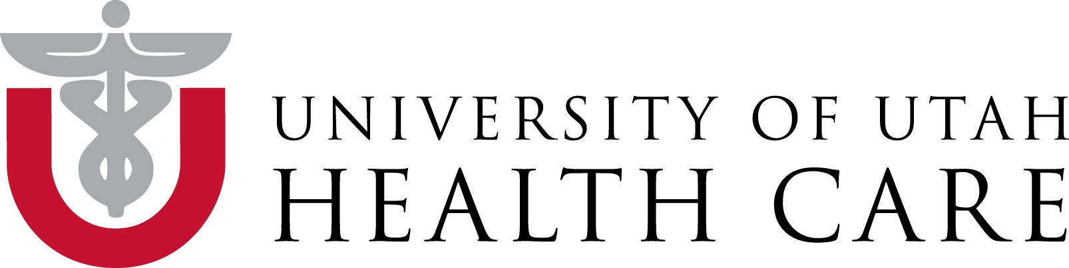
Shakti Krupa Charitable Trust

IMPROVING BIRTH OUTCOMES IN GUJARAT/INDIA
PROJECT SUMMARY
Birth asphyxia is the most common cause of newborn death in India resulting in 300,000 deaths annually. With simple newborn resuscitation measures ~90% of all asphyxia cases can be averted, yet most health providers conducting deliveries do not possess these life saving skills. This project, a collaboration between Primary Children’s Hospital/Intermountain Healthcare, the University of Utah - Office of Pediatric Global Health, the Shakti Krupa Charitable Trust and the Indian Academy of Pediatrics/Gujarat Ministry of Health, will fill this skill gap by introducing a standardized newborn resuscitation training program to health professionals in Gujarat involved in newborn care, improving critical case management skills of providers – Indian Newborn Resuscitation Program (INRP). The training curriculum, materials and mode of teaching are based on American Academy of Pediatrics guidelines (Helping Babies Breathe – HBB) following principles of adult learning theory and using previous experienceof conducting similar trainings in several other low-income nations. When completed, this project will have trained over 16,000 health providers in Gujarat state and will feature a novel web based birth outcome tracking system.
Our project provides master trainer courses, establishes training centers in several districts for future trainings and collaborates with the government on disseminating INRP throughout Gujarat.

IMPROVING CARE DELIVERY FOR CHILDREN WITH SEVERE ACUTE MALNUTRITION

Malnutrition is a significant public health problem in India, with early onset and high prevalence of wasting (30%) and stunting (20%) among children 0-5 months, and is a potentiating factor in 67% of deaths among children under age 5. Malnutrition in pregnancy is also a major cause of birth defects and low birth weight. Previous malnutrition interventions in the area had limited effectiveness.

Using national guidelines we implemented a malnutrition protocol at Mota Fofalia Hospital and are expanding our efforts to include community based health workers in a comprehensive treatment program which is supported by the government. We emphasize monthly weight and screenings and hospital referrals for deterioration in the condition. Our future plan is to deploy a simple mobile decision support tool that will be used by community health workers in India to screen pregnant women and children under age 5 for malnutrition, dramatically improving clinical care and referrals, thereby reducing mortality rates and preventing major birth defects. The mobile system will be deployed and tested by community health workers through a public-private partnership with the Mota Fofalia hospital and directorate of health services in Gujarat.

IMPROVING PEDIATRIC CARE QUALITY AT MOTA FOFALIA PEDIATRIC CENTER

Mota Fofalia Pediatric Center is a pediatric facility located in rural Gujarat. Medical management of complex cases in rural settings in resource limited area is challenging and gaps in patient care are common. In this quality improvement project, the University of Utah established a clinical service partnership with Mota Fofalia Children’s Hospital to improve care delivery at the patient level. The main focus of activities are improving care quality in the delivery room and for newborns, recognition of shock and establishing, monitoring and enforcing care standards that ensure patient safety and care quality. We use a quality improvement research methodology to identify gaps and design sustainable solutions and train a group of local providers in basics of QI management.

Current interventions:
- Introduction of care standards for medical and paramedical personnel: patient monitoring and charting, safety measures, handwashing and sanitation interventions for infection transmission prevention,
- Implementation of care process models for standard pediatric conditions: newborn care, low birth weight care, newborn infections; referral protocols
- Improving laboratory and ICU services, administrative and logistical hospital management
- Introducing a medical record and documentation system
- Implement telemedicine applications between institutions

We would like to thank the SORESON LEGACY FOUNDATION for their generous support of this program

MOTA FOFALIA PEDIATRIC CENTER Staff training programs

Availability of trained staff for a high acuity setting in rural India is scarce, yet a prerequisite for care quality. The University of Utah – Shakti Krupa Charitable Trust collaboration has identified staff training interventions as highest priority. Currently we run a nurse and paramedical staff training program following a 24 item core competency curriculum published by the Indian government. Trainings are conducted by University of Utah nurse master trainers, pediatric residents and faculty. Topics include pediatric shock recognition, taking and interpretation of vital signs, pediatric nursing care interventions (i.e. feeding tube placement) etc.

IMPROVING SURVIVAL OF LOW BIRTH WEIGHTH INFANTS

Low birth weight is the single most important risk factor for child death in developing countries. LBW babies are at higher risk of death due to infections (weakened immune system), inability to breastfeed (too weak) and inability to maintain a normal body temperature (risk of lethal hypothermia). Those who survive commonly stay malnourished throughout life, never reach their full intellectual and physical capacities and likely give birth to LBW children themselves thus perpetuating the cycle resulting in tremendous economic losses for society. 1 out of 10 children with low birth weight does not live to age 5.

Based on LBW best practice guidelines (WHO – Essential Newborn Care Package, Integrated Management of Pregnancy and Childbirth; WHO – Guidelines on optimal feeding of low birth weight infants) we developed a LBW clinical management algorithm for hospital and community based health workers defining treatment algorithms for optimal feeding, infection control and thermal management in resource poor settings
- We are training all hospital based staff (6 physicians, 9 nurses, 30 paramedical staff) in the Mota Fofalia pediatric center in LBW management, including the LBW care pathway and a standardized medical order set for LBW babies.
- Over the course of 1 years we will train 78 community health workers (Asha workers) in 40 villages of Sinor Taluka (area directly surrounding the hospital) in management of LBW infants as well as danger sign recognition and referral. At the same time we will reach out to communities through health fairs and other community engagement programs.

COMMUNITY OUTREACH AND HEALTH WORKER TRAINING PROGRAM

Community Health workers (CHW) are the first responders to illness. In the current state, they are poorly trained, poorly equipped and lack guidance about prioritization of their efforts to improve health of women and children in their communities. Specifically they lack training and skills in early identification of a sick child, identification and referral of severely malnourished children and providing services to high risk children such as LBW infants. CHW are the most important partners in health care delivery: they are the first responders to disease, have a long term relationship with their community and are members of a national organization of CHW salaried by the government of India. Yet, they remain a grossly under-utilized health resource.

The UU-Mota Fofalia project integrates CHW in their strategic project plan and steering committee. A strong community outreach project for early and correct identification of illness, provision of ongoing cares and adequate referral and care seeking is essential to success of public health programs in rural settings. 180+ CHW from surrounding areas will be included in training and care quality improvement interventions. In the upcoming year(s) we will develop and implement a comprehensive CHW training program, conducted through a collaborative effort between the University of Utah/Department Pediatrics, Pediatric residency program, Shakti Krupa Charitable Trust/Mota Fofalia hospital and government of India, Reproductive Child Health division

FUTURE PROJECTS

Improving anemia in women and children
Overcoming social barriers in accessing health care in low cast societies
Introduction of a high risk child surveillance program

